PROGRAM IDENTITIES – AREAS OF FOCUS | BRAND IDENTITY GUIDE
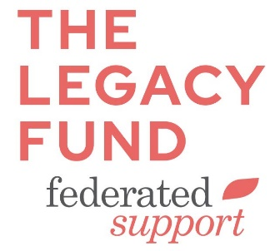
The Federated community welcomes all to “live your faith” through participation in various programs and ministries.

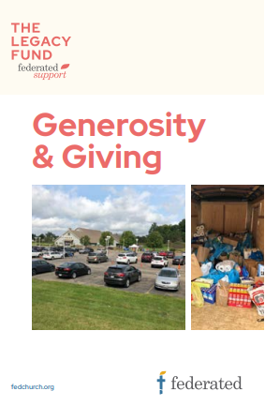
A program identity brandmark may now be created for each ministry name. There are four program identities that form a foundation for these groups to make up the Federated Community:
Example of program identity brandmark.
- Federated Support,
- Federated Worship,
- Federated Act and
- Federated Grow.

Be certain to include the primary Federated logo elsewhere on the page, generally at the bottom in the footer.

4 PROGRAM IDENTITIES
Example of brandmarks on brochure.

Areas of focus | Marks – never use alone; always include the main Federated logo | Programmatic focus | Program Identities by Commission | Notes
SUPPORT | 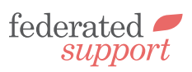 | Supporting each other | Congregational Care
WORSHIP | 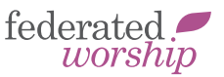 | Worshiping God together | Worship and Music
ACT |  | Working as the hands of Christ in our world | Mission and Service
GROW | 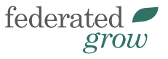 | Growing in faith and knowledge | Spiritual Formation

